**Step by Step guide for using VS Code and GitHub for deployments**

**Important Points:**

1. **We should have VSCode, Salesforce CLI Installed and Access to Github Repository**
2. **We are performing the deployment using corresponding Branch not through Sandbox**
3. Git Clone using URL <https://github.com/pgetech/ENERGY_INSIGHT_SFDX>
4. Type ctrl+shift+p in the terminal you will get a popup as shown below

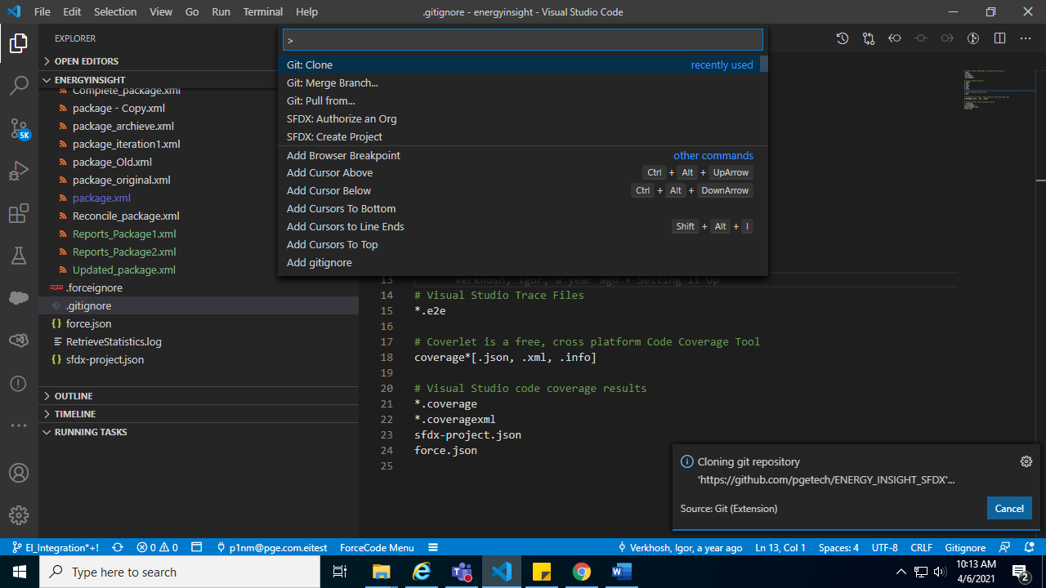

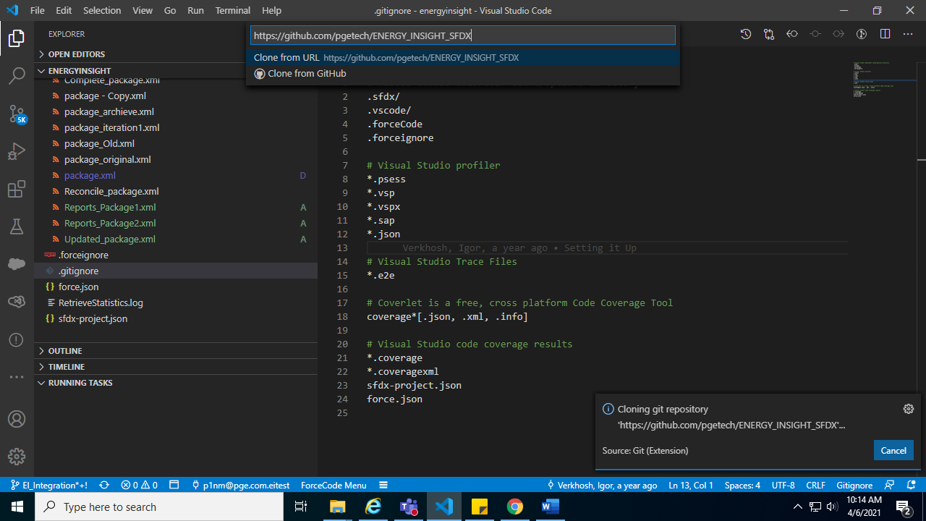

Local copy will be created at the selected location

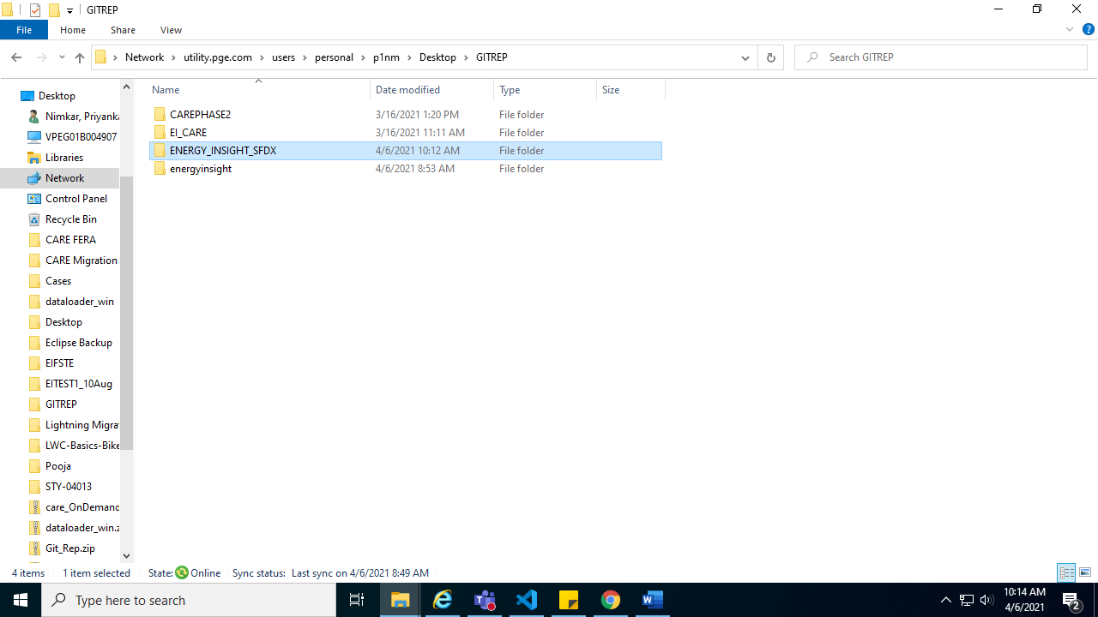

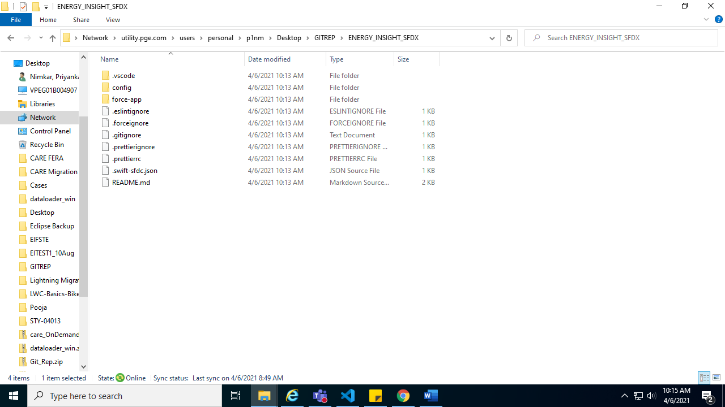

2) Go to VS Code and open folder

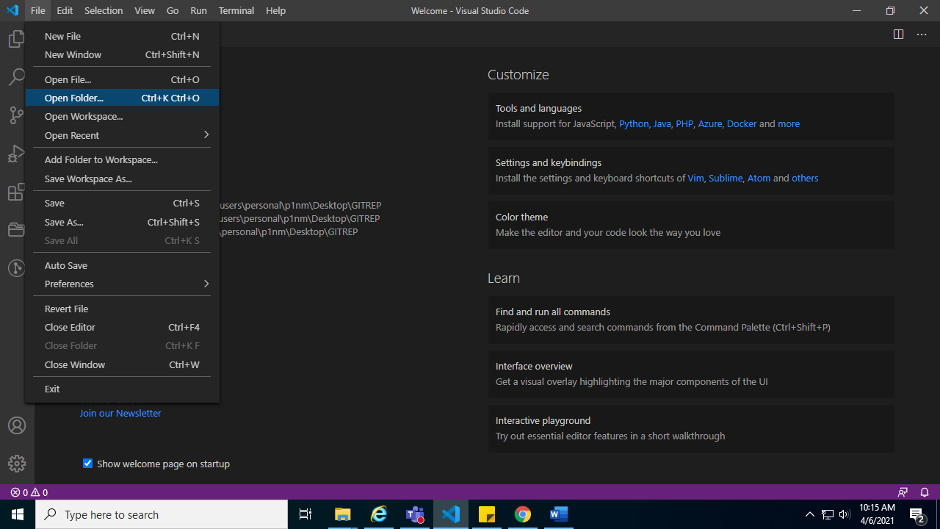

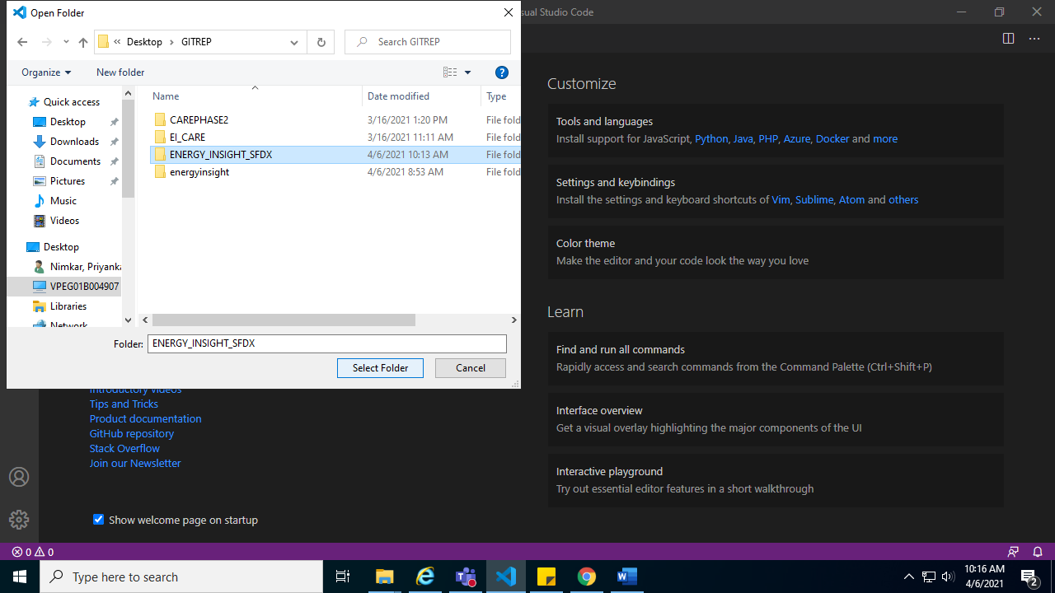

It looks like below. By default Main Local branch is selected

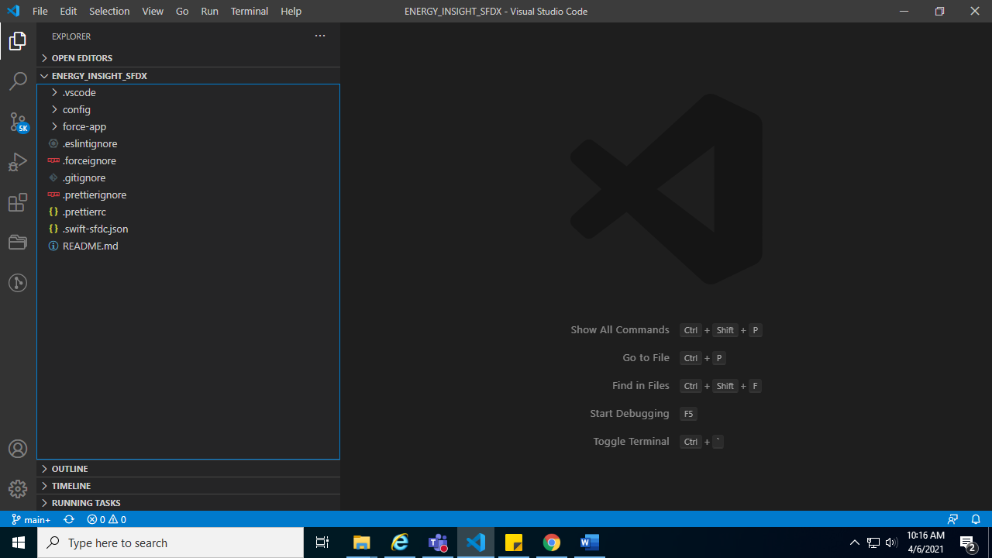

Switch to the branch from which you want to retrieve the package by clicking on left top bottom main Branch

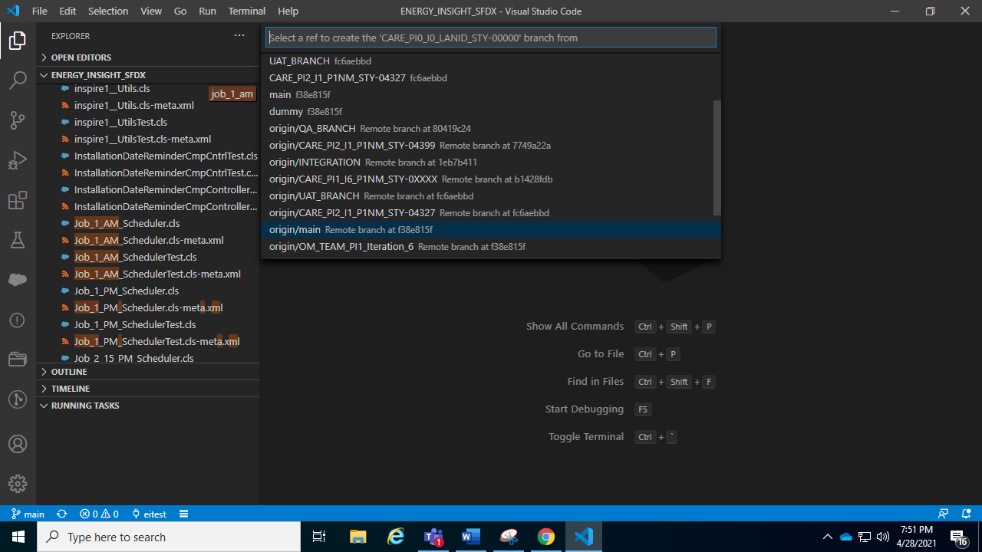

Inside manifest folder create the package.xml for particular story

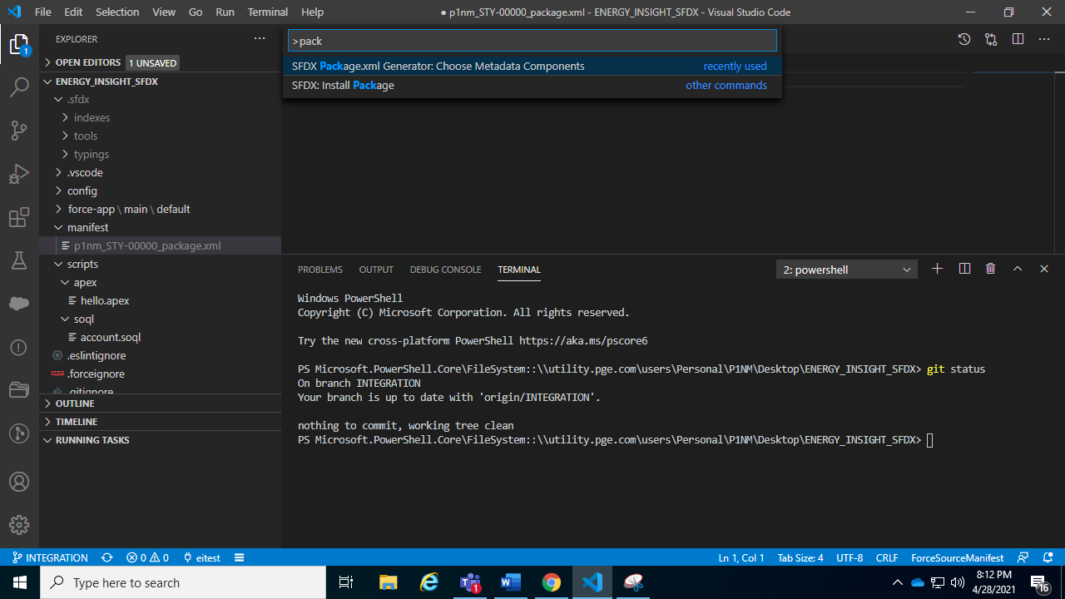

Run the command for validation

sfdx force:source:deploy -c -x manifest/package.xml -l RunLocalTests

Run the command for deployment

sfdx force:source:deploy -x manifest/package.xml -l RunLocalTests

This will start validation for the package, it will take approximately 15-20 mins for validation to show in deployment status

If you see any component or deployment failure, reach out to respective developer

To fix these errors.

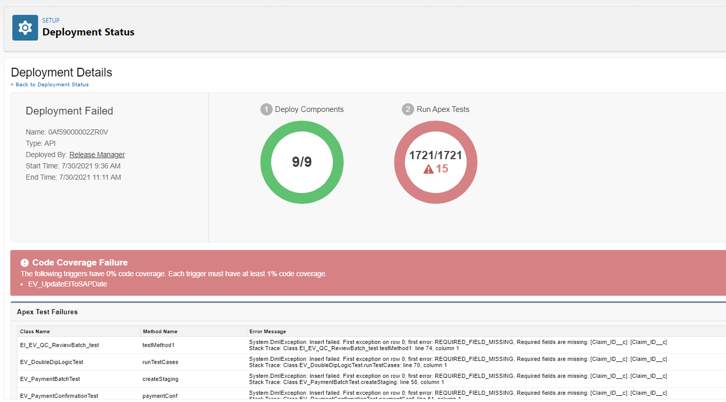

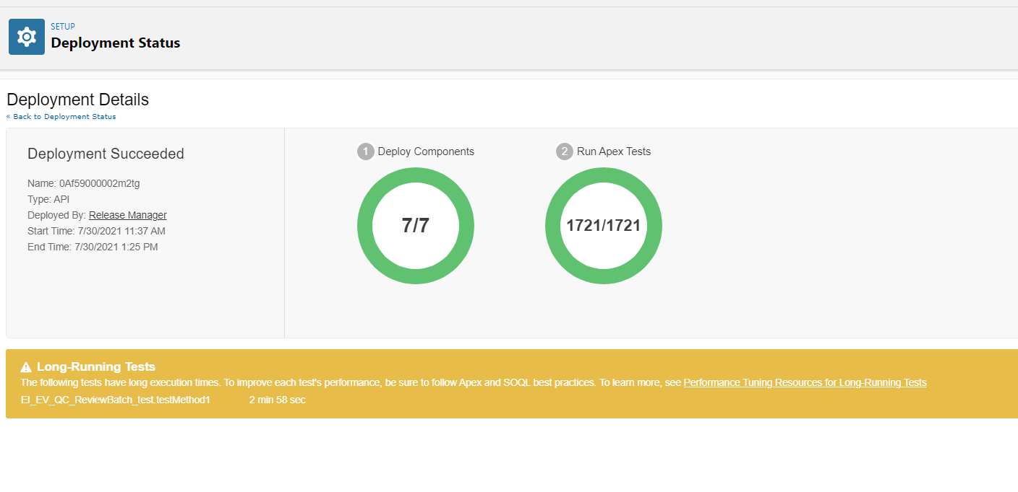

Once the deployment completed with no errors, update the DR.

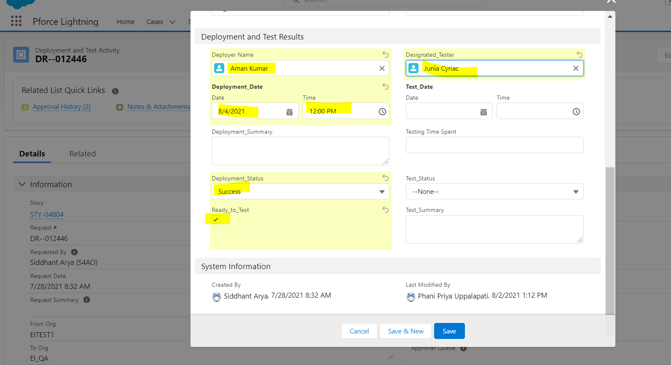

Thank You!!!